

System Admin

Training Assignments

|  |  |
| --- | --- |
| Program Code |  |
| Issue/Revision | x/y |
| Effective date | 04/Aug /2023 |

Assignment Day 09. System Software - Day 4

Mục Lục:

Hướng dẫn cài đặt Window Server 2022 2

Download the Windows Server 2022 ISO 3

Install Windows Server 2022 on VirtualBox 5

# Hướng dẫn cài đặt Window Server 2022

**Hardware requirements for Windows Server**

Minimum:

CPU: 1.4 GHz 64-bit processor

RAM: 512 MB (2 GB for Server with Desktop Experience installation option)

Disk 32G

## **Download the Windows Server 2022 ISO**

1. Go to the webste [Download link](https://www.microsoft.com/en-us/evalcenter/evaluate-windows-server-2022)

Or go to the website: <https://www.microsoft.com/en-us/evalcenter/evaluate-windows-server-2022>

2. Click on Download the ISO file as highlighted below.

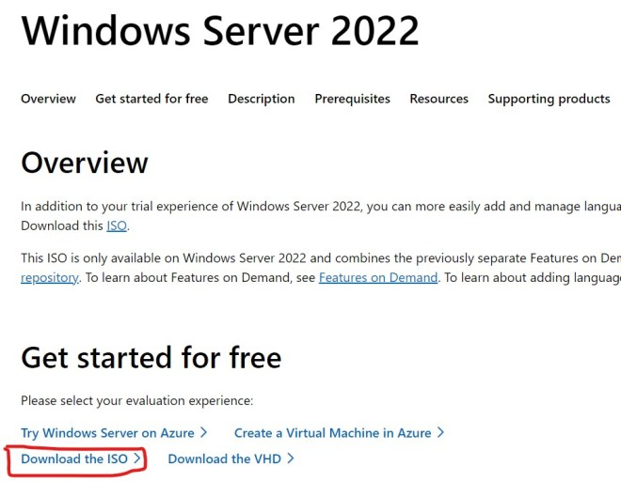

3. Fill all the data in Register page for and click on Download.

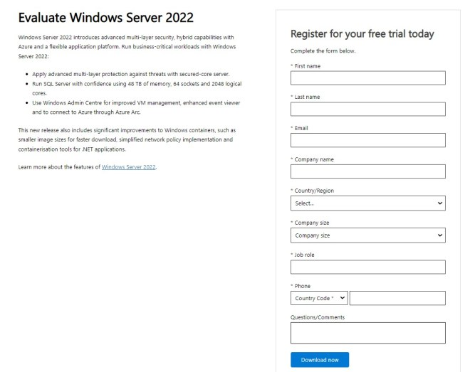

4. Click 64-bit edition.

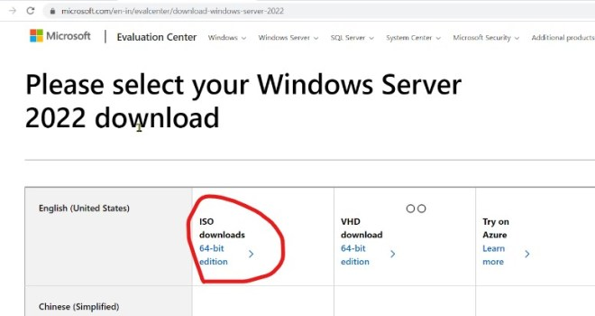

5. Wait until download completes.

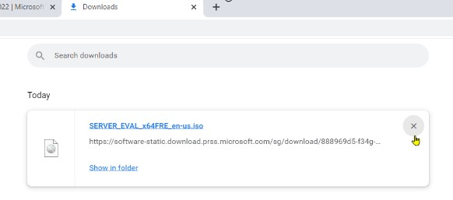

## **Install Windows Server 2022 on VirtualBox**

1. Open VirtualBox.

2. Click New as highlighted below in the VirtualBox.

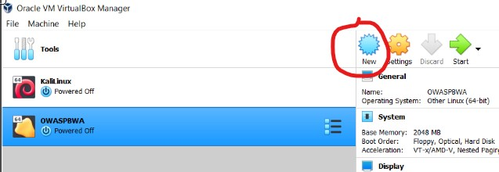

3. Provide the name for Virtual Machine, folder path to store the files and folders, Type windows, Version Other windows(If you dont find Windows Server 2022 in the drop down list). Then memory size and select Hard disk type.

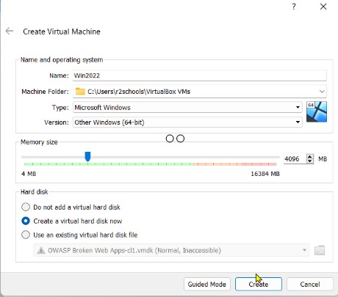

4. In the virtual hard disk, provide file location, file size, Hard disk file type, Storage type and click on create.

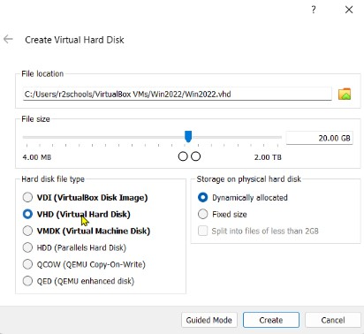

5. Click Virtual machine settings, then storage, Empty, Choose a disk file. Then attach the download ISO file.

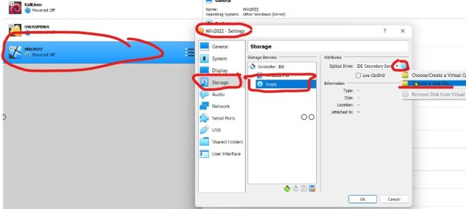

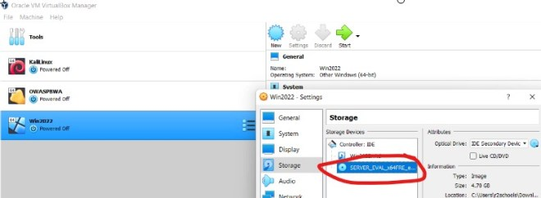

6. Now, click on Start butto to start Windows Server 2022 installation on VirtualBox as Virtual Machine.

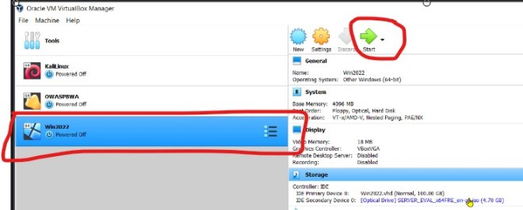

7. Click on next.

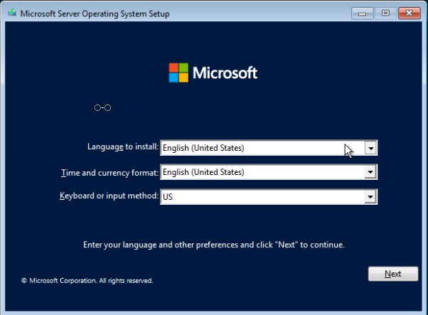

8. Click on Install.

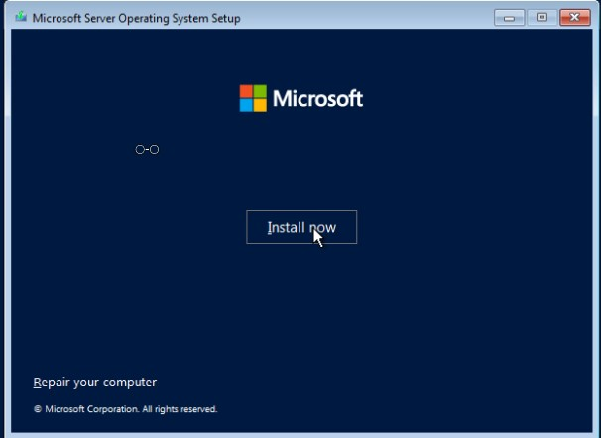

9. Select operating system that you want to install(Standard or Data Center) and click on Next.

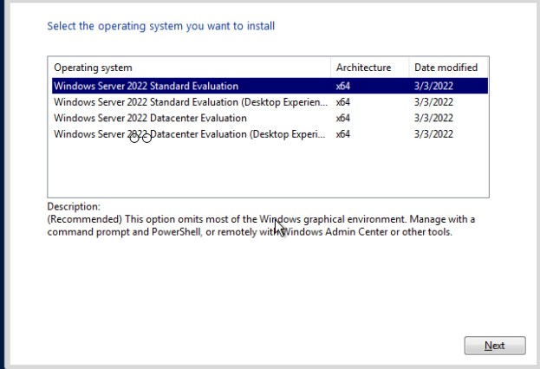

10. Select checkbox to accept Microsoft license terms and click on next.

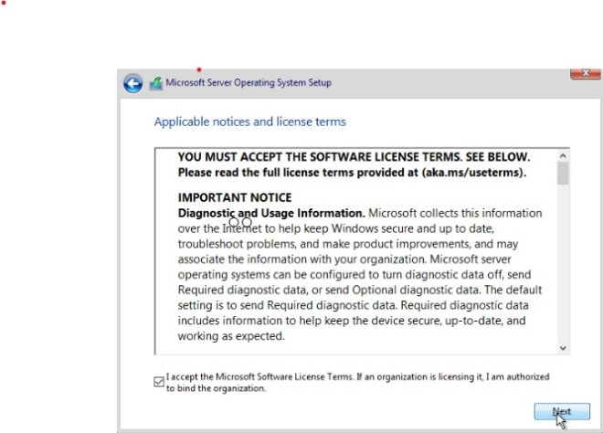

11. Select Custom type installation for fresh installation.

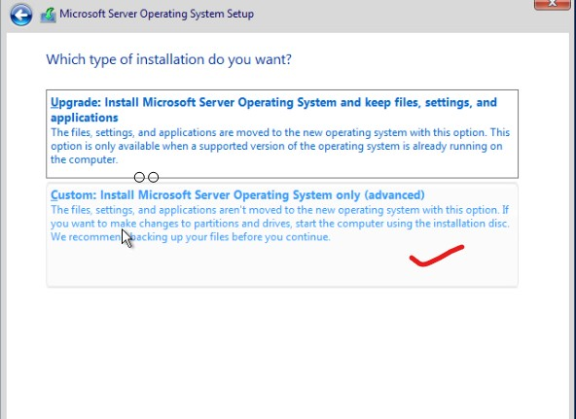

12. If you want to create a drive click on new(We can create drive after installation also). Otherwise just click on Next.

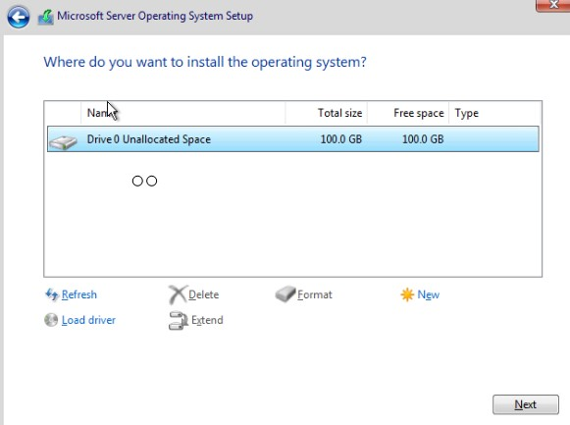

13. Wait until installation completes. After this completes, Virtual machine will be restarted.

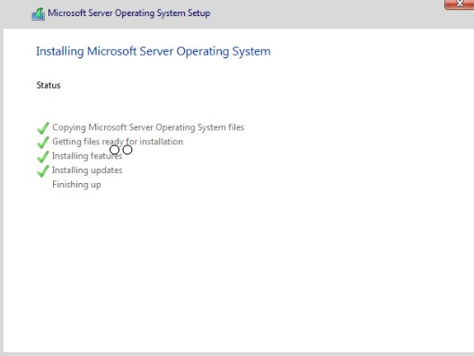

14. Now provide the password for built-in administrator account.

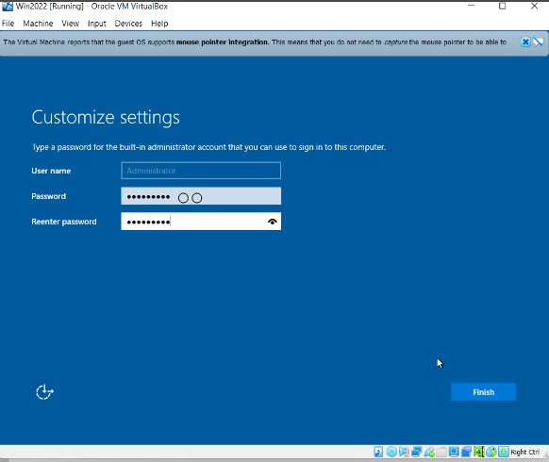

15. To unlock Windows Server 2022 virtual machine, click input–>Keyboard–>Select Insert Ctrl-Alt-Del.

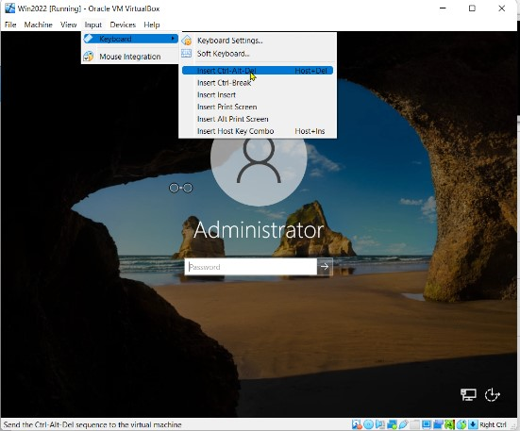

16. After login, we will get below console.

